**SYMBIOSIS SCHOOL, NASHIK**

**STD : X TERM I (2020-21)**

**SUB : BIOLOGY L.NO.9 HEREDITY AND EVOLUTION**

**WORKSHEET 1**

**Concepts : 1. Definitions**

**2. Monohybrid cross , Dihybrid cross**

**1. Definitions**

i) **Inheritance/Heredity :** The Process by which traits are transferred from one

generation to the next is called inheritance. It is the basis of heredity.

ii) **Genetics :** It Is the branch of science that studies the inheritance of traits.

iii) **Gene :** It is he functional unit of inheritance. It is the piece of DNA that carries

information for making a particular protein (trait).

iv) **Allele :** The different forms of same gene are called alleles

v) **Phenotype :** The external appearance of the organism is called the phenotype.

vi) **Genotype :** The genes present in the organism is called the genotype.

vii) **Homozygous :** When the two alleles are similar it is called homozygous.

viii) **Heterozygous :** When two alleles are different it is called heterozygous.

ix) **Dominant :** In heterozygous condition only one allele express itself. It is called

dominant.

x) **Recessive :** The allele that remain suppressed in heterozygous condition is

called recessive.

**3. Monohybrid Cross**

i) One pair of contrasting characters is studied. Mendel crossed homozygous tall plant **(TT)** with

homozygous dwarf plant **(tt)**.

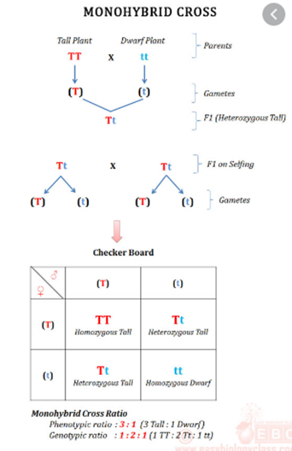

**4. Dihybrid cross**

i) Two pairs of contrasting characters are studied.

ii) Mendel crossed a plant homozygous for round and yellow seeds **(RRYY)** with a plant homozygous for

wrinkled green seeds **(rryy)**.

